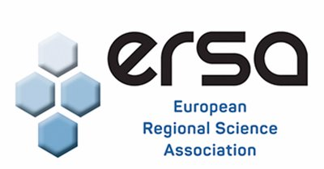
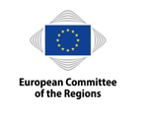
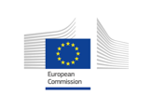
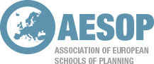

#EURegionsWeek Master Class on EU Cohesion Policy
Application form 2020
Deadline for submissions: 4th May 2020
Applications received after this date will not be accepted.

The completed application form should be combined with your CV and submitted in one document (WORD or PDF) via the online form (Google form).

I. Please provide your details

Name
Institution
Country
Email Address
Career Status
- PhD Student
- Early Career
- Early career applicant without a PhD and who is not currently PhD student*
Which #EURegionsWeek and Master Class theme does your paper fall under:
- Green Europe
- Cohesion and Cooperation
- Empowering Citizens
Title of your paper

II. Provide the outline of your paper (500 words excluding references) here:

III. Tell us how your current research relates to EU Cohesion Policy? (max. 250 words)

IV. What are your future research plans? (max. 250 words)

V. How will participation in this Master Class benefit your professional development? (max. 100 words)

VI. Academic reference
An academic reference in support of your application must be sent separately by the referee to Klara Sobekova at office@rsaeurope.org and be received by the closing date.

Please indicate:
Name of referee
Institution
Country
Contact details of the referee (address, email address and telephone number)
Relationship to the applicant (PhD supervisor, line manager etc…)

VII. Please tick to confirm
I confirm that the information given in this form is true, complete and accurate.
The completed application form should be combined with your CV and submitted in one document (WORD or PDF) via the online form.

Please submit your application and additional documents by the 4th May 2020 10.00am GMT or 11.00am (CET). For questions, please contact Klara Sobekova at office@rsaeurope.org.

As part of the application process, your details will be provided to the selection committee. Please see the RSA’s Privacy Statement at www.regionalstudies.org/privacy

